**Multi-Linear Regression**

**Example- Startup Dataset**

**Target variable is Profit**

**Summary 🡺**

|  |  |  |  |  |
| --- | --- | --- | --- | --- |
| **R.D.Spend** | **Administration** | **Marketing.Spend** | **State** | **Profit** |
| Min. : 0 | Min. : 51283 | Min. : 0 | California:17 | Min. : 14681 |
| 1st Qu.: 39936 | 1st Qu.:103731 | 1st Qu.:129300 | Florida :16 | 1st Qu.: 90139 |
| Median : 73051 | Median :122700 | Median :212716 | New York :17 | Median :107978 |
| Mean : 73722 | Mean :121345 | Mean :211025 |  | Mean :112013 |
| 3rd Qu.:101603 | 3rd Qu.:144842 | 3rd Qu.:299469 |  | 3rd Qu.:139766 |
| Max. :165349 | Max. :182646 | Max. :471784 |  | Max. :192262 |

**In the above summary all variables are continues except state because state is in categorial format.**

**Box Plot 🡺**

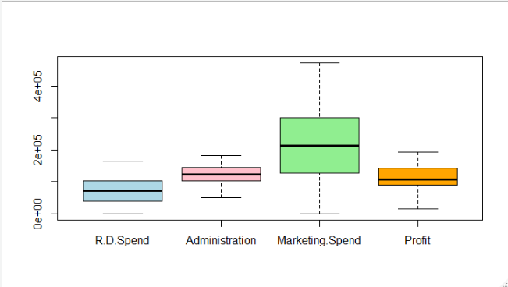

**From the above box plot we can infer that no outliers are present in data.**

**Pairs Plot 🡺**

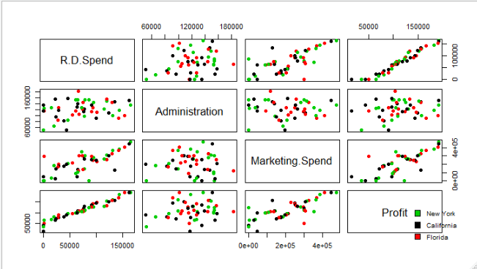

**Correlation 🡺**

|  |  |  |  |  |
| --- | --- | --- | --- | --- |
|  | **R.D.Spend** | **Administration** | **Marketing.Spend** | **Profit** |
| **R.D.Spend** | **1** | **0.241955245** | **0.724248133** | **0.972900466** |
| **Administration** | **0.241955245** | **1** | **-0.032153875** | **0.200716568** |
| **Marketing.Spend** | **0.724248133** | **-0.032153875** | **1** | **0.747765722** |
| **Profit** | **0.972900466** | **0.200716568** | **0.747765722** | **1** |

**Two variables in Administration and Marketing.Spend are negatively correlated and remaining are positively correlated with each other, so maybe there is no collinearity problem in independent variables.**

**Model-1 🡺**

model.S <- lm(Profit~R.D.Spend+Administration+Marketing.Spend)

Multiple R-squared: 0.9507, Adjusted R-squared: 0.9475

**Based on above R^2 value, 95% of variation in the profit because Administration is not significant where as Marketing.Spend in somewhat significant in our model.**

**AV Plot 🡺**

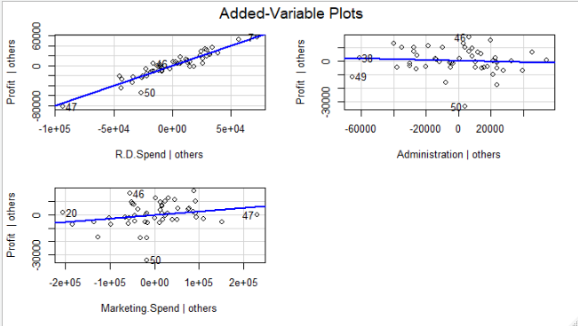

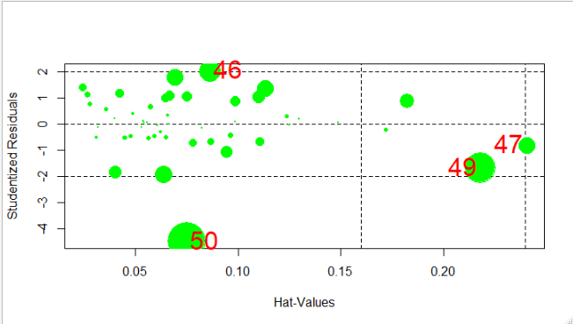

**From the above plot observations 46,47,49 and 50 are influence index so we can remove them from our model to get more accuracy.**

**Considering State as variable**

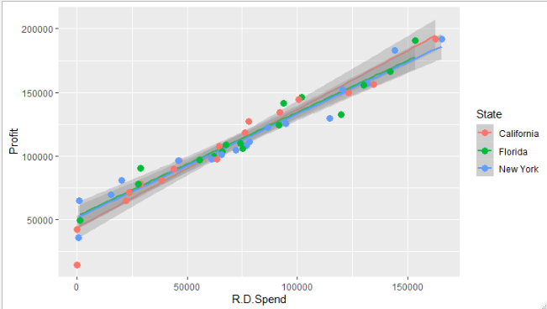

**Based on above plot , all the plots are overlapping with each other and only negligible difference between them. By removing state variable we will get same accuracy then no need to consider state variable , so we will not consider State variable in our model.**

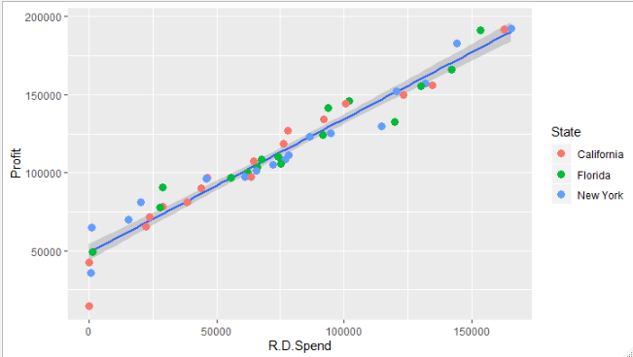

**Model-2 🡺**

model.S.2 <- lm(Profit~R.D.Spend+Administration+Marketing.Spend,data = df_Startups)

Multiple R-squared: 0.9626, Adjusted R-squared: 0.9599

rmse_2

6774.245

correlation is 0.9748282

**AV Plot 🡺**

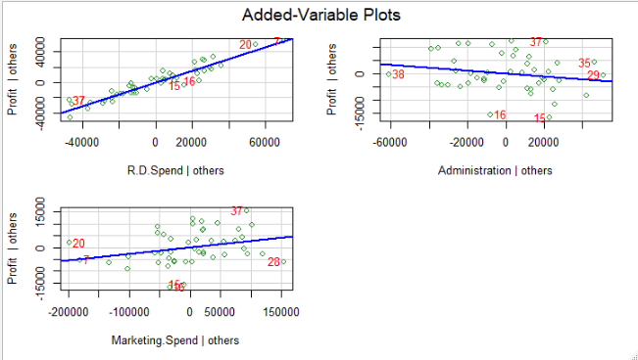

**From the above information, Administrative is insignificant in our model with only 79% confidence level.**

**Model-3 🡺**

model.S.3 <- lm(Profit~R.D.Spend+Marketing.Spend,data = df_Startups)

Multiple R-squared: 0.9612, Adjusted R-squared: 0.9594

RMSE value is 6899.99

Correlation is 0.9748121

**AV Plot 🡺**

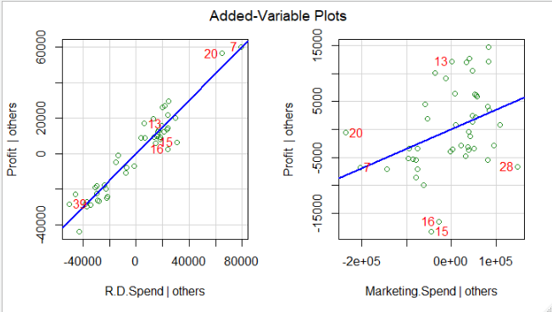

**After removing Administration we get probability of error for considering variable Marketing.Spend is 0.01 which is less than 0.05, so we can say it is significant variable in model.**

|  |  |  |  |  |
| --- | --- | --- | --- | --- |
| **Model No** | **Variable** | **R^2** | **RMSE** | **Cor(Y,predicted)** |
| **Model-1** | **All variable except State** | **0.9507** | **8855.344** | **0.975062** |
| **Model-2** | **Removed obs-46,47,49,50** | **0.9626** | **6774.245** | **0.9748282** |
| **Model-3** | **Removed variable Administration from Model-2** | **0.9612** | **6899.99** | **0.9748121** |

**Based on high R^2 and correlation between predicted and actual value and low RMSE Model-2 is good model.**